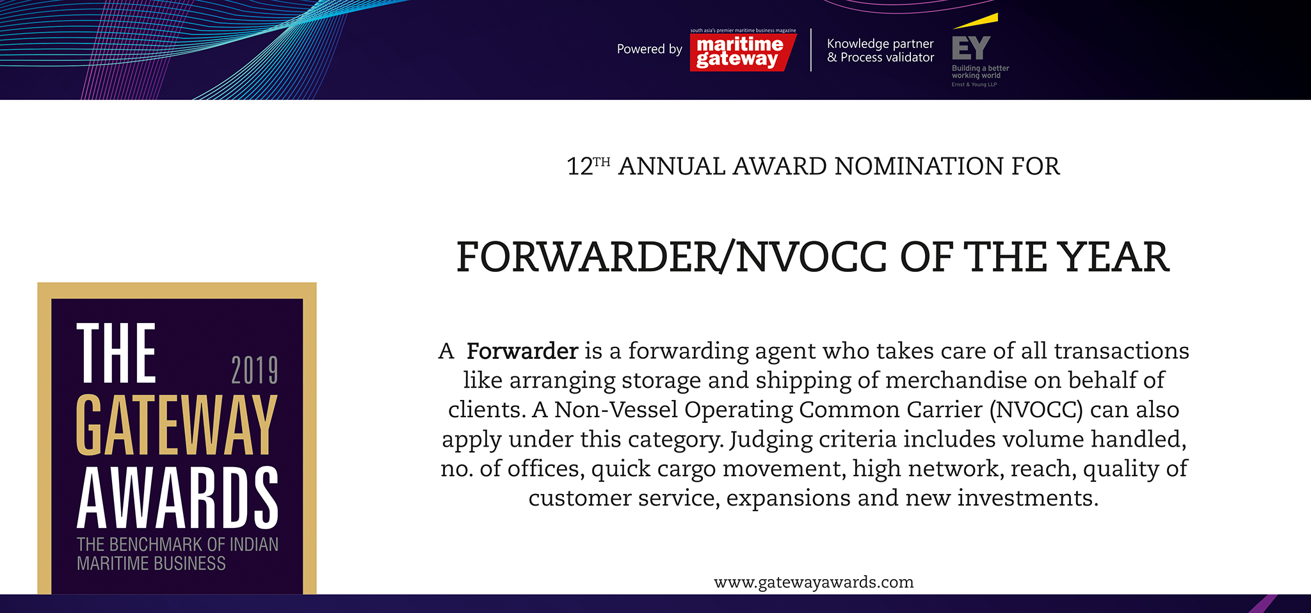

Please fill your responses and mail it to the address mentioned at the end of the Questionnaire

Note: All information and data should be provided for the FY 2018-19. In case, if you are unable to provide FY 2018-19 data, CY2018 information can be sent with a reason for not providing data for FY 2018-19.

Contact information:
Name of the Organization

Contact Person

Designation

Contact no.

Official Email ID

Address

Performance Indicators

Parameters | Units | Inputs
Non-containerized cargo Volume | Million Tonnes
Containerized cargo Volume | TEUs

Efficiency Indicators

Parameters | Units | Inputs
Y-O-Y Growth in non - Containerized cargo | Percent
Y-O-Y Growth in - Containerized cargo | Percent
Network reach - no. of offices in India | Number
Network reach - no. of offices globally | Number
No. of offices at ports | Number
Total no. of customs files handled | Number
Total warehousing capacity | SQ Meters

Innovations/ Investments/ Enhancements

Parameters | Type of inputs needed | Inputs
Innovations | • Qualitative inputs  • Word limit ~ 200 words.
Business Processes

Efficiency

Technology

Investments made

Please use below contact for sending filled-in form and also for any queries.

Rakesh Oruganti | Cell: +91 99483 34568;E mail ID: rakesh.oruganti@gatewaymedia.in

